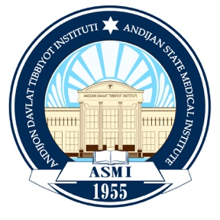

ASMI CLIMATE ACTION PLAN (Until 2030)

1. Introduction
Andijan State Medical Institute (ASMI) acknowledges the urgent global challenge posed by climate change and is committed to minimizing its environmental impact. ASMI aims to align with the United Nations Sustainable Development Goals (SDGs) and national sustainability priorities.
This Climate Action Plan outlines the strategies, actions, and targets ASMI will pursue through 2030 to reduce its ecological footprint, enhance climate resilience, and move toward long-term carbon neutrality.

2. Objectives and Goals (By 2030)
By 2030, ASMI aims to achieve the following key objectives:
- Achieve significant progress toward carbon neutrality, reducing institutional emissions year by year.
- Reduce overall energy consumption by 30% through efficiency upgrades and responsible energy use.
- Decrease campus waste generation by 50% and increase recycling and reuse to at least 70%.
- Expand the use of renewable energy, with the long-term goal of transitioning to 100% clean energy sources.
- Build a fully integrated culture of sustainability among students, faculty, and staff through education, training, and engagement.

3. Strategies and Actions

3.1 Energy Efficiency and Renewable Energy:
To reduce energy consumption and support renewable energy generation, ASMI will:
Implement advanced energy efficiency programs across academic, administrative, and clinical buildings, including LED retrofits, smart meters, automated energy management systems, and strategies to reduce peak-hour loads.

Expand the installation of solar panels and explore additional renewable options such as hybrid systems to power campus operations. Support research, innovation, and academic projects focused on clean energy, green technologies, and sustainable infrastructure—promotion of energy-conscious behavior programs among students and staff.
Projected Energy Consumption Reduction (2025-2030):

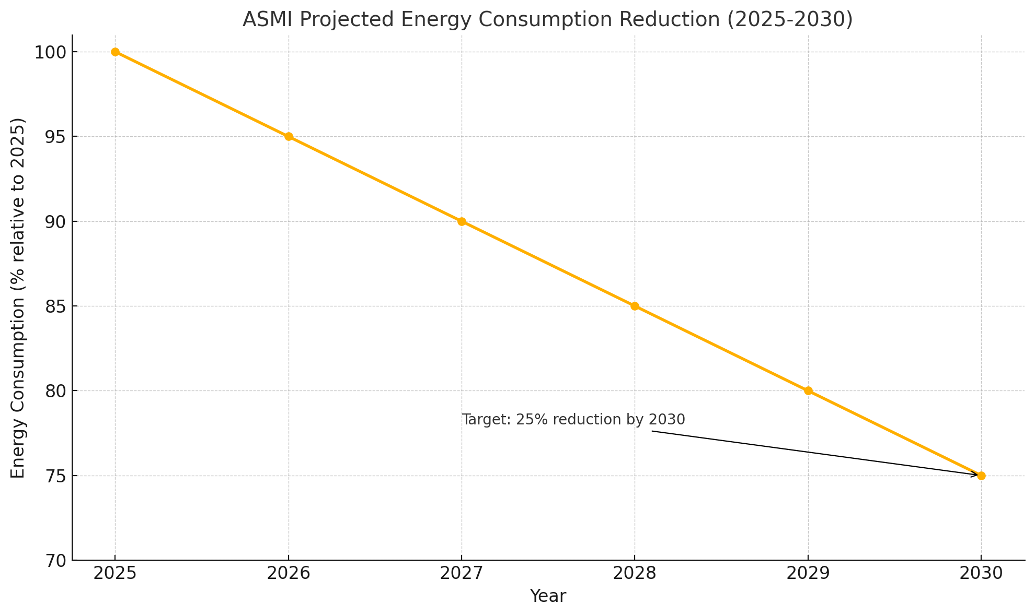

3.2. Water and Waste Management
To reduce waste by 50% and increase recycling to 70%, ASMI is implementing:
- Advanced water recycling and purification systems to optimize resource use.
- A zero single-use plastic policy across all university operations.
- Expanded composting programs and waste segregation practices.
- Development of a smart waste management system with AI-based monitoring and
- optimization.

Waste Management Goals (2025-2030)
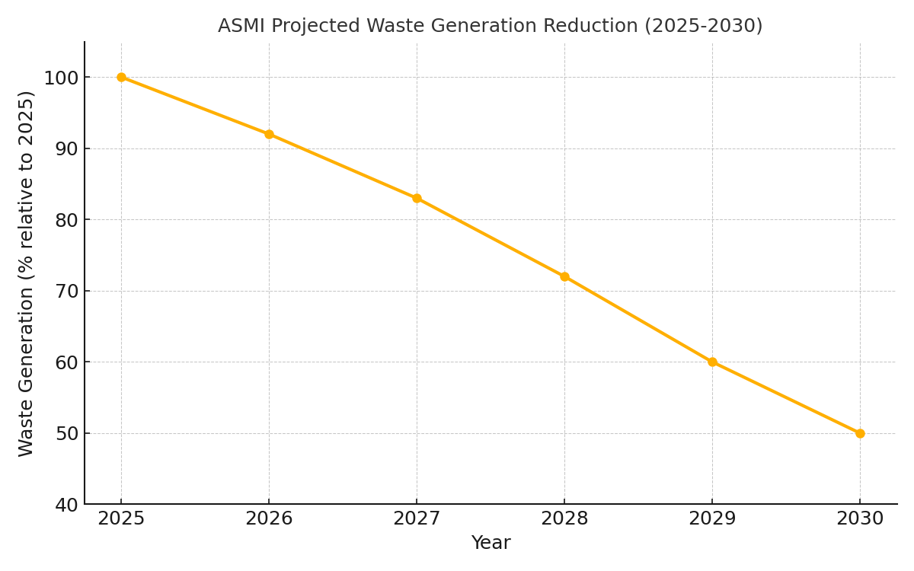

3.4. Carbon Neutrality Goal by 2030
ASMI is committed to achieving carbon neutrality by 2030 by implementing strategic reductions in emissions and investing in long-term sustainability solutions. The Institute will reduce direct (Scope 1) and indirect (Scope 2) emissions, introduce low-carbon technologies, and support offsetting measures only for emissions that cannot be eliminated.
To reach this target, ASMI will:
- Phase out fossil fuel–based energy consumption across campus operations and transition toward cleaner, renewable energy sources.
- Offset unavoidable emissions through carbon capture initiatives, tree-planting programs, and green infrastructure development.
- Partner with local, national, and international sustainability organizations to support innovation, knowledge exchange, and collaborative climate action.

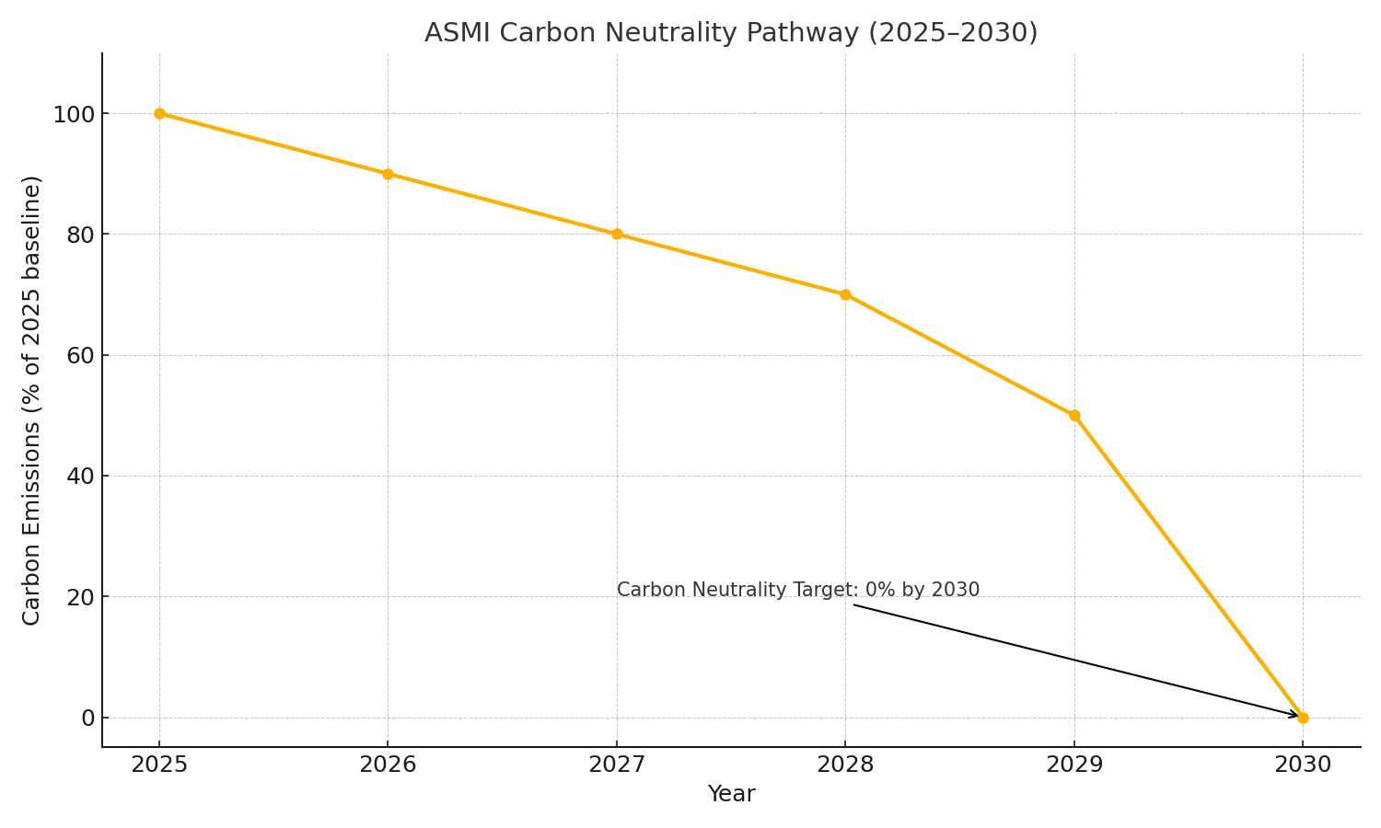

4. Monitoring and Evaluation
ASMI will ensure the successful implementation of its Climate Action Plan through continuous monitoring, transparent reporting, and evidence-based evaluation. Key measures include:
- Publishing an annual Sustainability and Climate Action Report that includes transparent metrics, progress indicators, and performance benchmarks.
- Conducting regular carbon footprint assessments to monitor reductions in Scope 1, Scope 2, and—where possible—Scope 3 emissions.
- Aligning institutional reporting with recognized international sustainability frameworks and rankings such as the UN SDGs, QS Sustainability Rankings, and the GHG Protocol.
- Engaging third-party auditors to verify sustainability data, ensure accountability, and strengthen the credibility of ASMI’s climate reporting.

5. Conclusion and Future Directions
By 2030, Andijan State Medical Institute aims to position itself as a regional leader in climate action and sustainability. Through systematic improvements in energy efficiency, waste management, renewable energy adoption, research innovation, and sustainability integration across academic and administrative operations, ASMI is committed to making a lasting positive impact on the environment and public health.
Strong collaboration with key stakeholders—including students, faculty, government agencies, industry partners, and international organizations—will be essential to achieving the ambitious goals outlined in this Climate Action Plan. ASMI remains dedicated to advancing sustainability, strengthening climate resilience, and contributing to Uzbekistan’s national development priorities.
