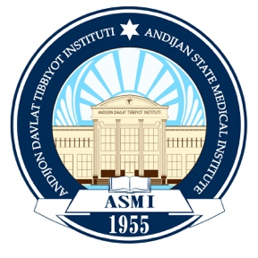

ASMI NET ZERO PROGRAM (2025–2035)

1. Introduction
Andijan State Medical Institute (ASMI) is committed to achieving Net Zero Carbon Emissions by 2035 through a comprehensive and strategic sustainability roadmap. This Net Zero Program aligns with global climate frameworks, including the Paris Agreement, the UN Sustainable Development Goals (SDGs), and Uzbekistan’s national environmental priorities. It outlines ASMI’s long-term commitment to reducing emissions, transforming campus operations, and advancing environmental stewardship.

2. Key Objectives (By 2035)
ASMI aims to achieve the following institutional Net Zero goals:
- Reduce total carbon emissions by 90% through energy-efficiency upgrades and large-scale adoption of renewable energy.
- Achieve 100% renewable energy supply by transitioning to solar, hybrid, and other clean-energy technologies.
- Eliminate fossil fuel use across university facilities, transportation systems, and procurement processes.
- Reduce waste generation by 60% and increase campus-wide recycling rates to 80%.
- Promote a sustainable campus culture, integrating climate education, green operations, and student/faculty engagement into institutional practices.
- Implement carbon offset initiatives—such as reforestation, green landscaping, and carbon-capture programs—to neutralize unavoidable emissions.

3. Key Strategies & Actions

3.1 Renewable Energy Transition
ASMI will take the following steps to ensure a full transition to clean energy:
- Upgrade all academic, clinical, and administrative buildings to Net Zero Energy standards, improving insulation, efficiency systems, and energy monitoring.
- Expand solar photovoltaic capacity, introducing additional installations and rooftop systems to meet campus electricity demand.
- Deploy battery storage systems to ensure stable and continuous clean energy supply.
- Conduct annual renewable energy audits to measure progress and improve system performance.

3.2 Renewable Energy Transition
ASMI will implement a comprehensive renewable energy strategy to support its Net Zero 2035 goal. Key actions include:
- Upgrading all academic, clinical, and administrative buildings to Net Zero Energy standards, incorporating advanced insulation, efficient HVAC systems, and real-time monitoring.
- Expanding solar photovoltaic capacity through rooftop installations, ground-mounted arrays, and integration into new building designs.
- Introducing battery storage systems to maintain stable, uninterrupted renewable power supply across the campus.
- Conducting annual renewable energy performance audits to evaluate system efficiency and monitor progress.
- Installing smart energy management systems to optimize energy use, reduce losses, and improve overall operational efficiency.
- Developing additional solar and wind energy projects, including feasibility assessments for mixed renewable technology deployment.
- Conducting regular energy audits to measure improvements, verify savings, and ensure alignment with ASMI’s Net Zero roadmap.
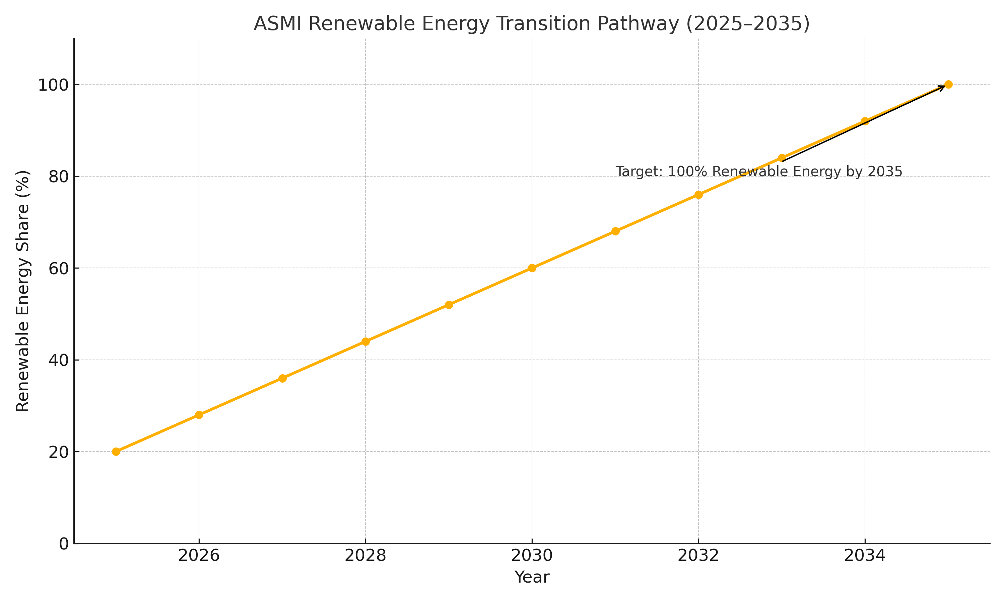

3.2 Sustainable Transportation
ASMI is committed to decarbonizing all transportation-related activities as part of its Net Zero strategy. The Institute will implement the following actions:
- Electrify the university fleet, replacing fuel-based vehicles with electric or hybrid alternatives.
- Promote public transport, carpooling, and shared mobility, reducing single-occupancy vehicle use across the ASMI community.
- Develop a pedestrian- and bicycle-friendly campus, including safe walkways, bicycle lanes, and secure parking facilities.
- Introduce smart mobility policies, integrating digital systems for tracking emissions, optimizing transport routes, and improving efficiency.
These efforts align with SDG 11 (Sustainable Cities & Communities) and SDG 13 (Climate Action).
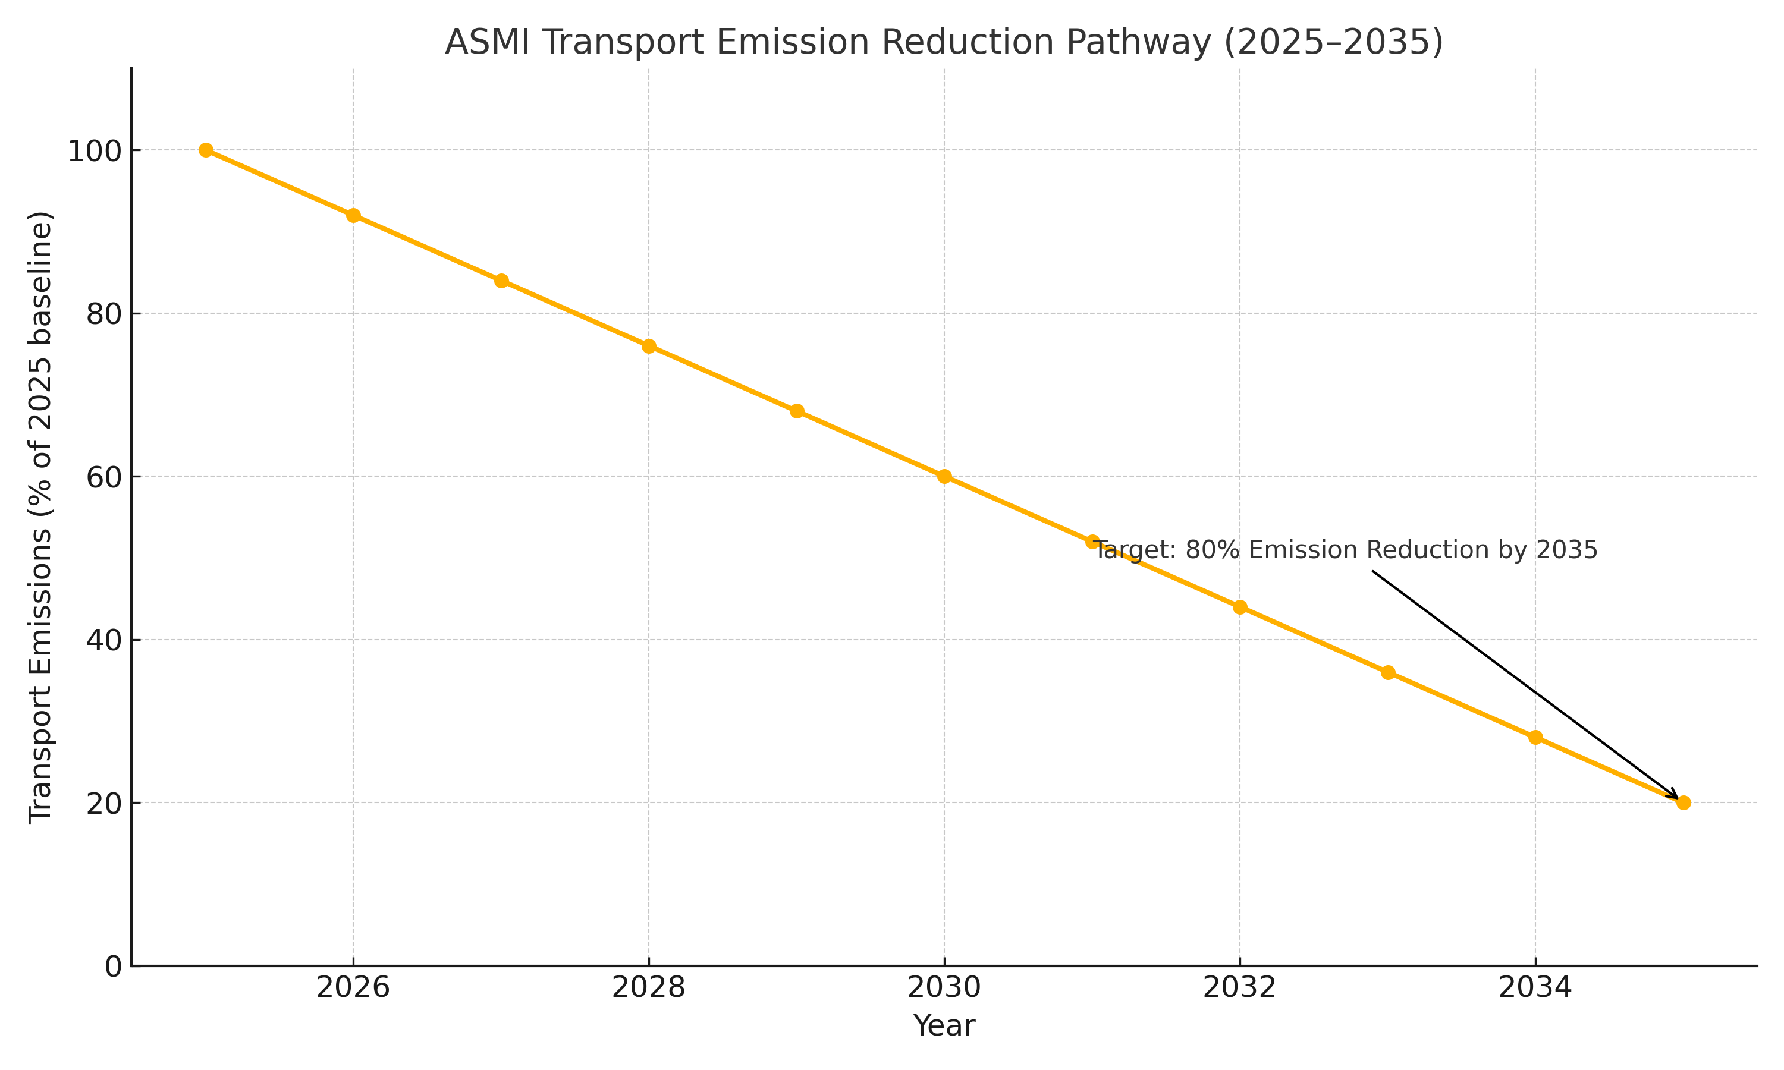
3.2 Sustainable Transportation
ASMI is committed to decarbonizing all transportation-related activities as part of its Net Zero strategy. The Institute will implement the following actions:
Electrify the university fleet, replacing fuel-based vehicles with electric or hybrid alternatives.
Promote public transport, carpooling, and shared mobility, reducing single-occupancy vehicle use across the ASMI community.
Develop a pedestrian- and bicycle-friendly campus, including safe walkways, bicycle lanes, and secure parking facilities.
Introduce smart mobility policies, integrating digital systems for tracking emissions, optimizing transport routes, and improving efficiency.
These efforts align with SDG 11 (Sustainable Cities & Communities) and SDG 13 (Climate Action).

3.3 Waste Management & Circular Economy
ASMI is committed to adopting a circular economy framework that prioritizes waste reduction, resource efficiency, and sustainable material use. The Institute will implement a campus-wide transformation to minimize environmental impact and support national and global sustainability goals.
ASMI will focus on the following key actions:
- Achieve a Zero-Waste Campus by reducing landfill waste, maximizing material recovery, and shifting toward sustainable consumption patterns.
- Implement comprehensive composting and recycling programs, including segregation of medical, organic, plastic, paper, and electronic waste streams.
- Ban single-use plastics across all campus facilities, events, and procurement processes to eliminate unnecessary waste and promote reusable alternatives.
These actions align with SDG 12 (Responsible Consumption & Production) and support ASMI’s long-term vision of environmental stewardship.
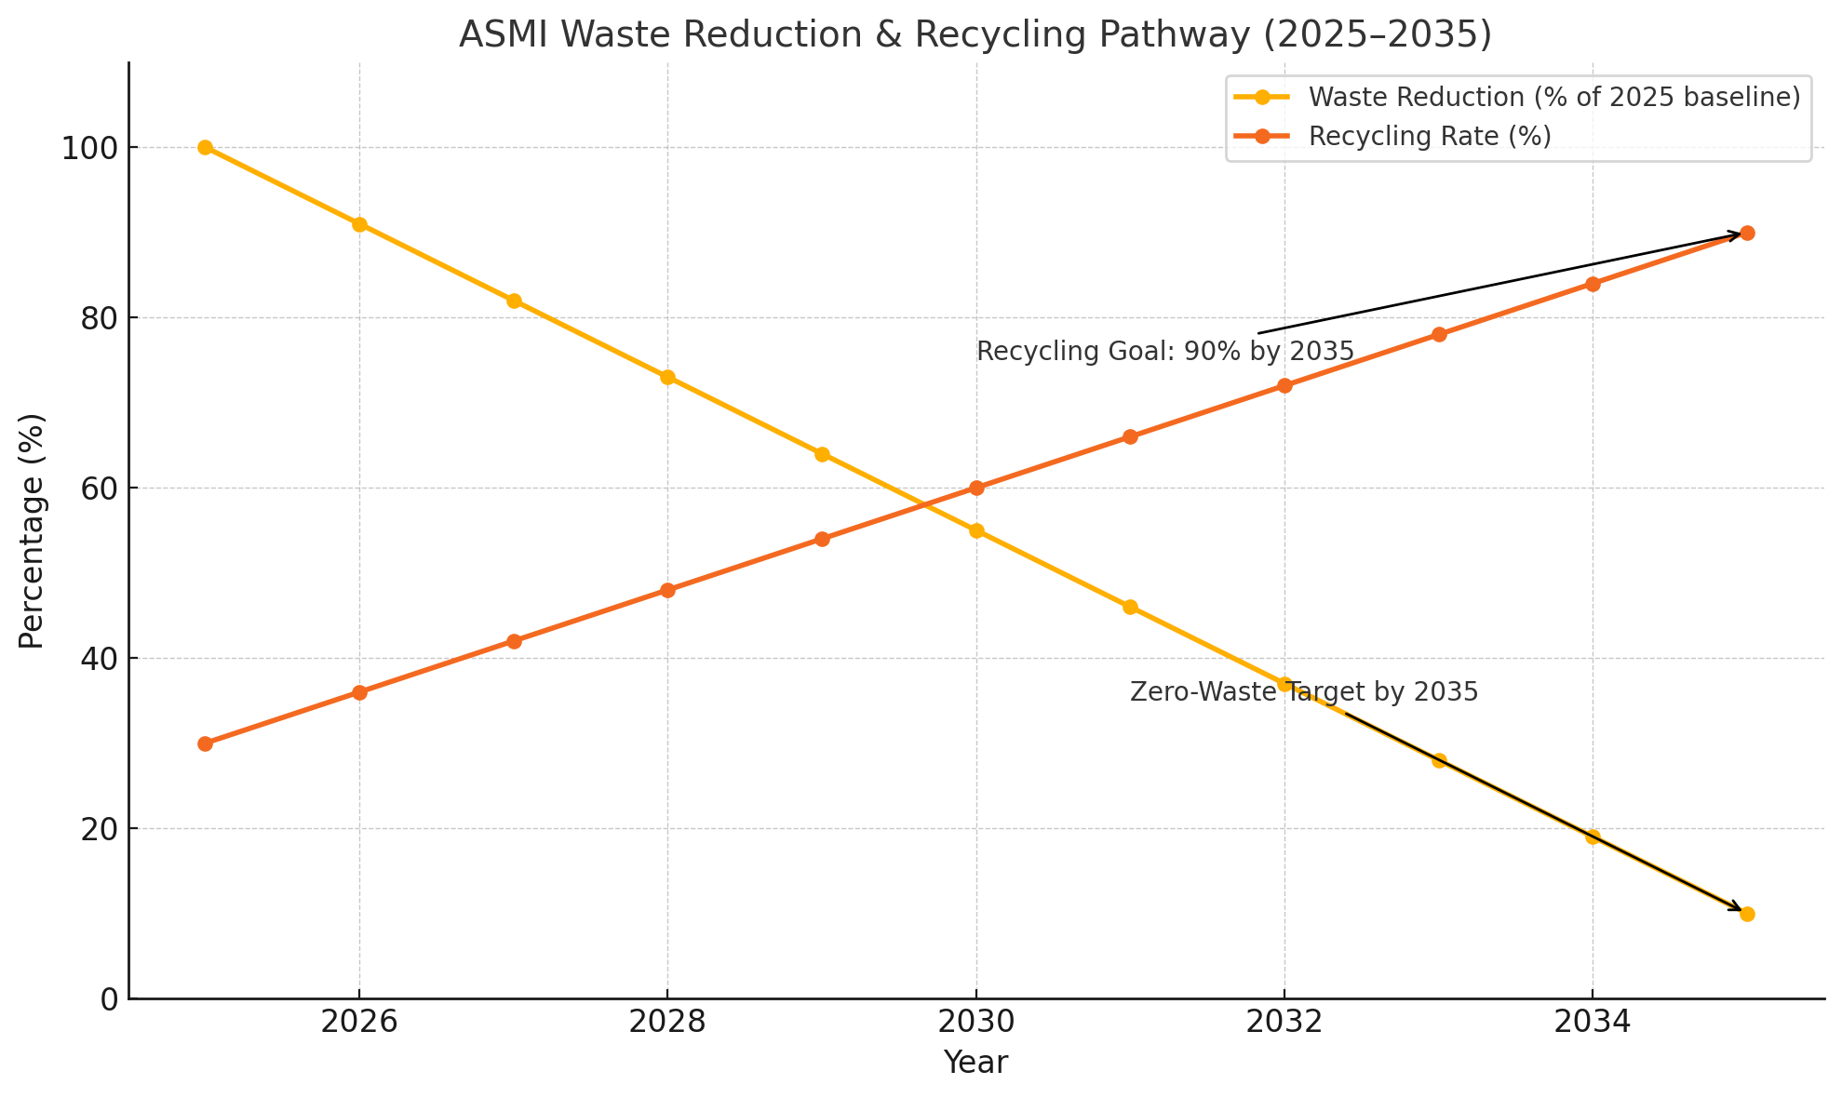

3.4 Carbon Offset & Green Infrastructure
ASMI will support its Net Zero 2035 goal through strategic carbon-offset initiatives and the development of climate-resilient, nature-based infrastructure. These actions complement emission-reduction measures and help neutralize unavoidable emissions.
Key actions include:
- Launching a Carbon Offset Initiative, including large-scale tree-planting programs, afforestation, and carbon-capture activities designed to remove atmospheric CO₂.
- Developing green roofs, green walls, and sustainable landscaping, improving air quality, reducing heat island effects, and increasing campus biodiversity.
- Expanding green infrastructure across new and existing buildings, integrating natural cooling systems, permeable surfaces, and eco-friendly materials.
- Partnering with environmental agencies and NGOs to support high-quality verified offsets and ecosystem restoration projects.
These initiatives support SDG 13 (Climate Action) and SDG 15 (Life on Land).
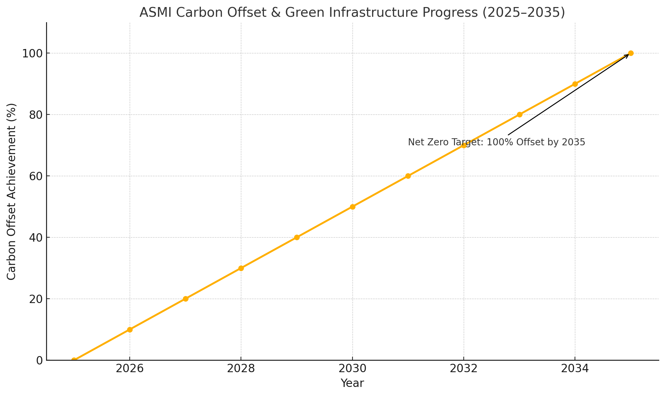

4. Monitoring & Reporting
ASMI will ensure transparency, accountability, and continuous improvement through a robust monitoring and reporting framework. Key mechanisms include:
- Publishing Annual Sustainability Reports aligned with the UN Sustainable Development Goals (SDGs), detailing progress toward Net Zero commitments and institutional environmental performance.
- Implementing real-time carbon tracking dashboards to monitor energy consumption, emissions, waste, and renewable energy generation across campus facilities.
- Engaging third-party auditors to validate emission data, renewable energy performance, and overall compliance with international sustainability standards.
- Integrating sustainability into education and research, ensuring that students and faculty actively contribute to climate action initiatives, innovation, and sustainable development practices.
This framework ensures that ASMI’s progress is measurable, transparent, and internationally comparable.

5. Conclusion & Future Vision
By 2035, Andijan State Medical Institute (ASMI) aims to become a fully Net Zero institution, eliminating its carbon footprint through comprehensive emission reductions, renewable energy adoption, and high-quality carbon offset programs. ASMI aspires to serve as a leading example of sustainable higher education in Uzbekistan and the broader Central Asian region.
Through continued innovation, community engagement, and strong partnerships with governmental, academic, and environmental organizations, ASMI is committed to building a resilient, sustainable, and climate-responsible future for generations to come.
