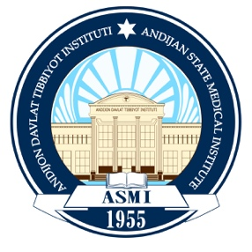

Sustainable Development Goals (SDGs)

What Are the Sustainable Development Goals?
The Sustainable Development Goals (SDGs)—also known as the Global Goals—were adopted by the United Nations in 2015 as a universal call to action to end poverty, protect the planet, and ensure that all people enjoy peace, health, and prosperity by 2030.
The 17 SDGs are interconnected, recognizing that progress in one area supports progress in others. Achieving them requires balancing social, economic, and environmental sustainability while prioritizing support for the most vulnerable populations. The SDGs aim to eradicate poverty and hunger, promote equality, enhance global health, and safeguard the rights of women and girls.

Sustainability at Our Institute
Sustainability—the foundation of the SDGs—is embedded across all academic, administrative, and community activities of the University. SDG principles are integrated into:
- Academic programs and curriculum
- Research projects and innovation
- Library and learning resources
- Volunteer and community engagement initiatives
- Student festivals, clubs, and leadership programs
Through these initiatives, the University empowers students, faculty, and staff to become informed and active contributors to sustainable development.

ASMI SDG Hub
The ASMI SDG Hub plays a central role in advancing SDG implementation by:
- Providing access to reliable, relevant SDG-related knowledge resources
- Offering expert language and communication support for government and partner institutions
- Facilitating dialogue, collaboration, and capacity-building initiatives
- Establishing partnerships with local and international private sector organizations, NGOs, and government bodies
- Supporting research, innovation, and learning activities aligned with the SDGs. These efforts strengthen the University’s mission to contribute meaningfully to national and global sustainable development.

The Role of Education in Sustainable Development
Creating a sustainable world requires individuals who are capable of driving positive change. To become sustainability change-makers, learners need the knowledge, skills, values, and attitudes that support responsible decision-making and long-term global wellbeing.
As stated by UNESCO (2017, p.7):
“Education is crucial for the achievement of sustainable development.”
Our University is committed to ensuring that every learner gains the competencies needed to contribute to the achievement of the SDGs.

Sustainability: On the Path to Net Zero
Andijan State Medical Institute (ASMI) is committed to becoming a leading institution for sustainability in Uzbekistan. We are working to position ourselves as a sustainable, climate-responsible university dedicated to environmental protection, social responsibility, and long-term institutional resilience.
ASMI aligns its sustainability commitments with the United Nations Sustainable Development Goals (SDGs) through effective resource management, innovative teaching and learning, research excellence, national and international partnerships, continuous improvement, and community outreach.
To advance the SDGs institution-wide, ASMI will undertake the following actions:
- Establish high-level sustainability and steering committees;
- Evaluate institutional alignment with each SDG;
- Develop SDG-related policies and guidelines;
- Conduct awareness and training campaigns across the ASMI community;
- Establish a Sustainability Office to coordinate initiatives.
- Identify SDG relevance for each faculty, department, program, and laboratory;
- Implement sustainability-focused projects and initiatives across campus.

Sustainability Team
F. B. Rasulov: Vice-Rector for the International Relations Department
G.Z.Saliyev: Dean of the Faculty of International Students
I.D.Yusupov: Assistant to the Vice-Rector at the Department of International Relations
M.D.Abdumalikov: Senior Specialist at the Department of International Relations

Vision
ASMI strives to contribute to the goals of Uzbekistan–2030 and the UN Sustainable Development Goals (SDGs) by advancing sustainability, public health, medical education, and scientific innovation within Uzbekistan’s higher education system.

Mission
In alignment with the “Uzbekistan-2030” Strategy and the strategic priorities of ADMI, the Institute integrates the SDGs into its mission by delivering high-quality education, promoting sustainability initiatives, supporting lifelong learning, strengthening scientific research, and expanding community service activities.

ASMI Scope 1 and Scope 2 Inventory Guidance
Scope 1 emissions represent the direct greenhouse gas (GHG) emissions released from sources that are owned or controlled by ASMI. These include emissions produced from on-site fuel combustion such as boilers, furnaces, backup generators, institute-owned vehicles, and certain laboratory or medical gas systems.
Scope 2 emissions represent indirect GHG emissions resulting from ASMI’s purchased electricity, steam, heating, or cooling. Although these emissions occur off-site—at the facility where the energy is generated—they are included in ASMI’s GHG inventory because they are a direct consequence of the Institute’s energy consumption.
ASMI’s GHG accounting framework follows the GHG Protocol and provides an overview of emission sources across the value chain, distinguishing between direct (Scope 1) and energy-related indirect (Scope 2) emissions. This structure supports transparency, accurate reporting, and long-term carbon reduction planning

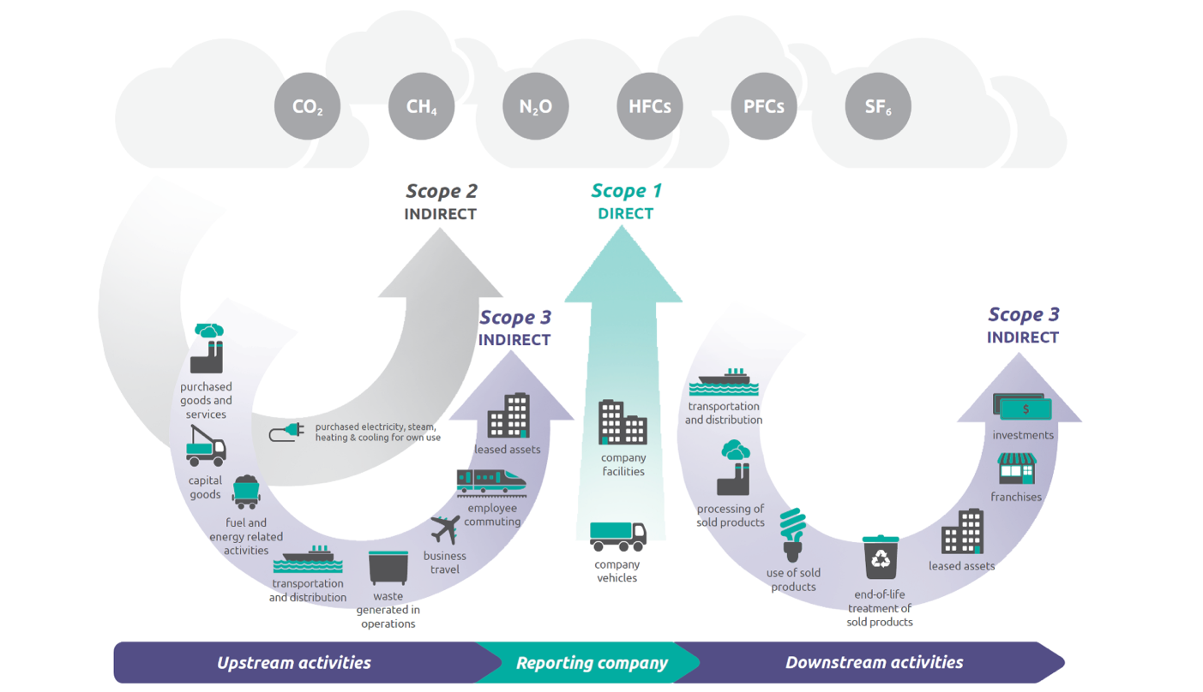
Source: page 5.
The following EPA guidance documents describe methods to calculate and report emissions from these sources.
Direct Emissions from Stationary Combustion (pdf) (632.72 KB, December 2020)
This document is used to identify and estimate direct GHG emissions from stationary (non-transport) combustion of fossil fuels at a facility (eg, boilers, turbines, process heat).
Direct Emissions from Mobile Combustion Sources (pdf) (683.82 KB, December 2020)
This document is used to identify and estimate direct GHG emissions associated with fuel combustion in owned or operated mobile sources.
Indirect Emissions from Purchased Electricity (pdf) (430.87 KB, December 2020)
This document is used to identify and estimate indirect GHG emissions resulting from the purchase of electricity, steam, heat, or cooling.
Direct Fugitive Emissions from Refrigeration, Air Conditioning, Fire Suppression, and Industrial Gases (pdf) (850.27 KB, December 2020)
This document is used to identify and estimate direct emissions of GHGs from refrigeration and air conditioning systems, fire suppression systems, and the purchase and release of industrial gases.
The GHG Protocol published a standard that standardizes how corporations measure emissions from purchased or acquired electricity, steam, heat, and cooling.
Note: Many industrial sectors also have process-related emission sources that are specific to their sector. EPA's Greenhouse Gas Reporting Program provides guidance and tools that can aid in the calculation and reporting of these emissions.

PHOTOS:
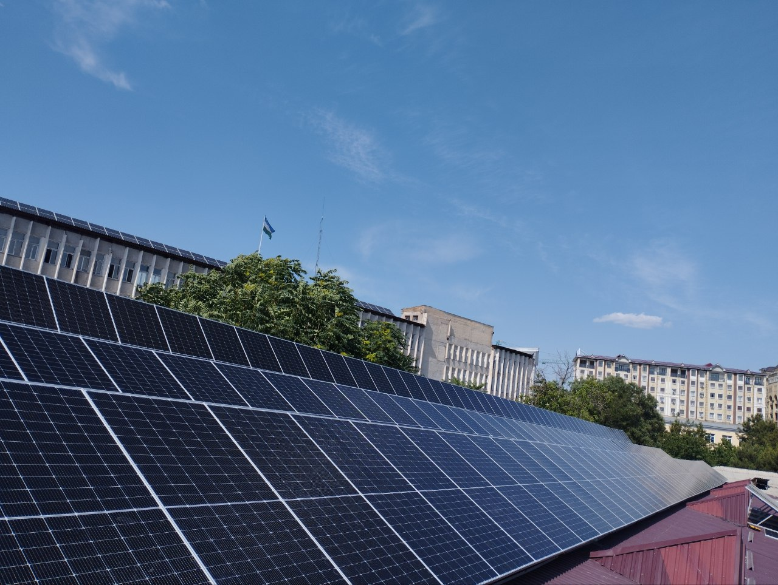

SOLAR ENERGY SYSTEMS AT ASMI

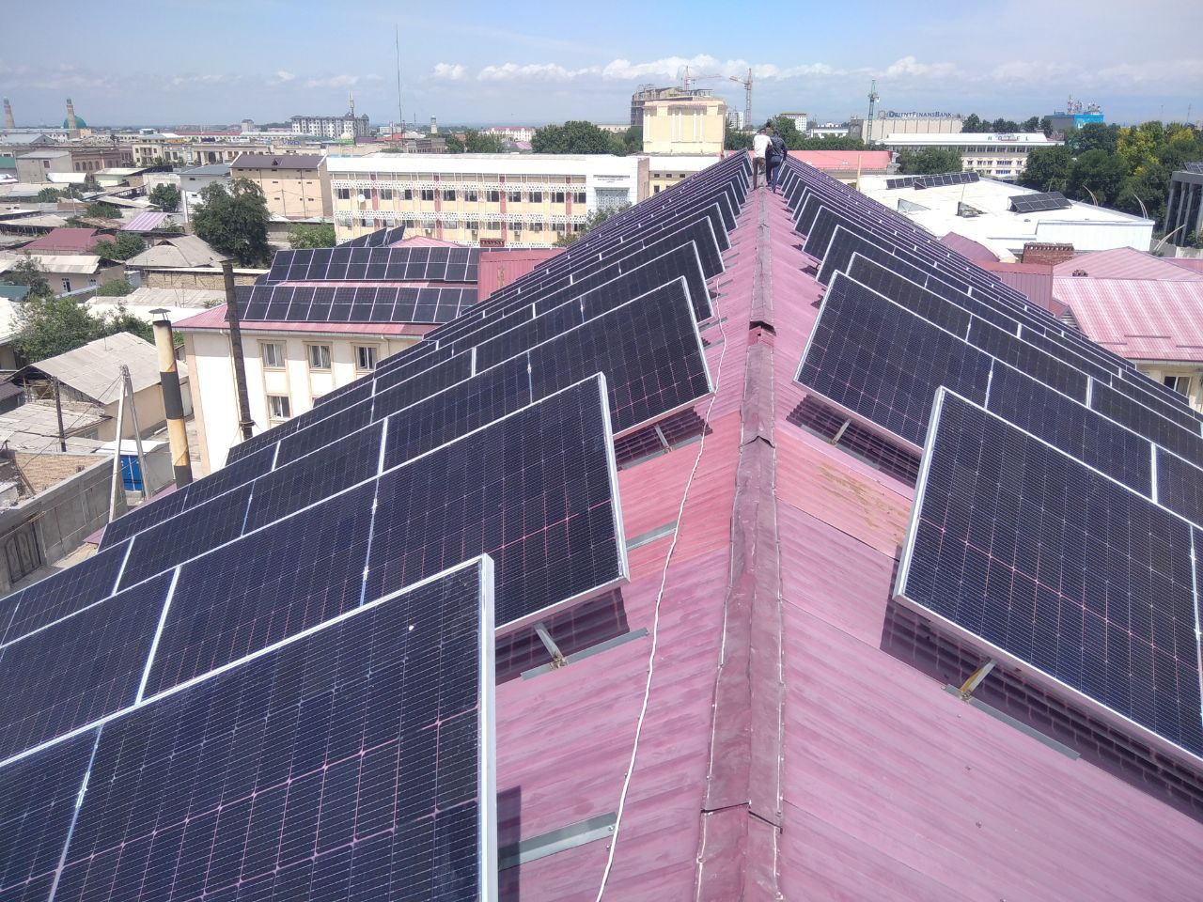
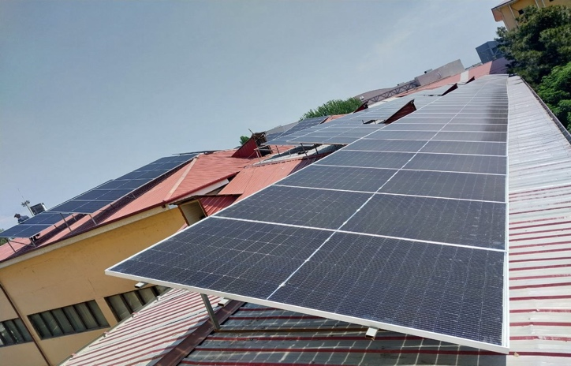

GREEN INSTITUTE

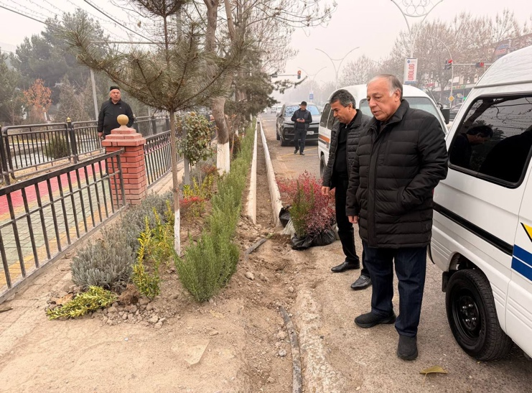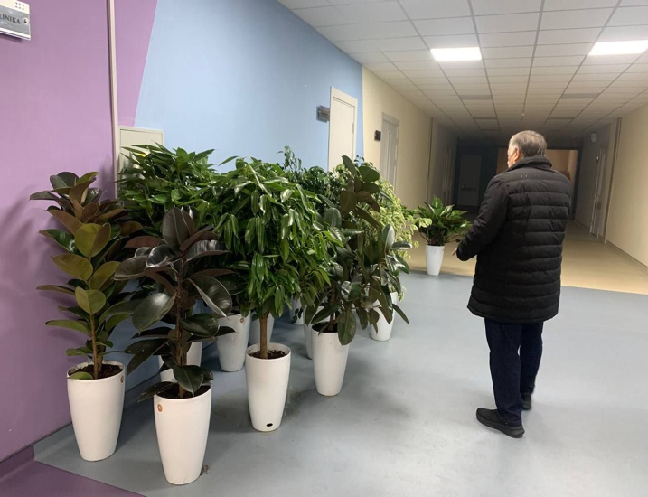

Reports:

ASMI Sustainability Infrastructure and Renewable Energy Achievements
- Solar Water-Heating Collectors (70 units): Each collector heats 5 liters per hour, providing a combined capacity of 300 liters/hour, significantly reducing reliance on traditional heating systems and lowering energy consumption.
- Solar Photovoltaic Panels (195 units, 100 kWh capacity): Installed to generate clean electricity and reduce dependence on grid power. The 2022 baseline for Scope 1 & 2 emissions is 85 tCO₂e, providing a reference point for future reductions.
- Solar-Powered Outdoor Lighting (45 units): Enhances campus lighting efficiency and reduces electrical load, advancing ASMI’s renewable energy transition.
- Water Treatment System (20,000-liter capacity): Supports sustainable water management and improves resource conservation on campus.
- Transition to Full Solar Integration (launched in 2023): ASMI has initiated a multi-phase plan to transition academic buildings and campus infrastructure to solar energy.
- LED Energy-Efficient Lighting (640 lamps, 9060 kWh savings): Upgraded lighting systems reduce electricity consumption and contribute to long-term operational efficiency.
- Carbon Footprint Assessment: Total organizational carbon footprint measured at 251.2 metric tons of CO₂e, forming the baseline for future emission-reduction strategies.


