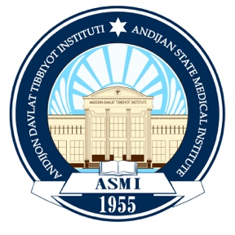

ANDIJAN STATE MEDICAL INSTITUTE

Gender Equality Policy

1. Purpose
Andijan State Medical Institute (ADTI) is committed to promoting gender equality and ensuring equal rights, opportunities, and treatment for all students, academic staff, administrative employees, and applicants regardless of gender. The Institute strives to create an inclusive, respectful, and discrimination-free learning and working environment in accordance with the Constitution of the Republic of Uzbekistan, national legislation, and the United Nations Sustainable Development Goal 5 (Gender Equality).

2. Scope
This policy applies to:
- Academic and administrative staff;
- Undergraduate, graduate, and postgraduate students;
- Researchers;
- Applicants;
- Visitors and institutional partners.

3. Policy Principles
ADTI is committed to:
- Providing equal opportunities in admission, employment, promotion, and professional development regardless of gender;
- Ensuring equal access to education, research, scholarships, leadership positions, and institutional resources;
- Preventing all forms of gender discrimination, harassment, bullying, and violence;
- Promoting gender balance in committees, decision-making bodies, and leadership positions whenever possible;
- Supporting work-life balance and equal participation in academic and professional activities.

4. Institutional Commitments
The Institute shall:
- Maintain transparent and fair recruitment and admission procedures;
- Ensure equal pay for equal work in accordance with national legislation;
- Encourage women's participation in science, research, innovation, and leadership;
- Organize awareness programs, seminars, and training on gender equality and non-discrimination;
- Provide confidential mechanisms for reporting discrimination or harassment.

5. Responsibilities
University leadership, faculty members, staff, and students are responsible for:
- Respecting the rights and dignity of all individuals;
- Promoting an inclusive and respectful academic environment;
- Reporting any incidents of discrimination or harassment through established institutional procedures.

6. Monitoring and Review
The implementation of this policy shall be monitored by the Institute's administration and relevant departments. The policy shall be reviewed periodically to ensure compliance with national legislation and international best practices.

7. Effective Date
This policy shall take effect upon approval by the Rector of Andijan State Medical Institute and shall remain in force until amended or replaced.
